A Project on

Web Based Student

Attendance System

Guide: Dhokate D.D.

Project Group Members:

1.Shaikh Mohamad Y.

2.Patel Nidhi V.

3.Mohite Sarika S.

4.Chougule Aarti A.

* Relevance

Attendances of every students are being maintained by every school, college and university. Faculty has to maintain proper record for the attendance. The manual attendance record system is not efficient and requires more time to arrange record and to calculate the average attendance of each student. Hence there is a requirement of a system that will solve the problem of student record arrangement and student average attendance calculation. The proposed system should store the absent and present student’s attendance details in electronic format so that management of attendance becomes easy.

Old conventional methods for student attendance is still used by most of the universities. As this method is used, many students are helping their friends by signing in their attendance in case of their absent in the institute. So while this method is used, attendance records are analysed and maintained manually by the faculty to know the present and absent student list. The faculty has to take attendance again if the attendance sheet is being lost and in this case absent students get chance to make their present in new sheet.

This procedure, besides being troublesome for lecturer, it will also affect students as time is expended on signing, verifying and submitting the attendance sheet manually. Therefore, a computerized system that can manage and help the lecturers to take attendance easily and maintain that attendance has to be developed. The faculty can easily access this system. Manipulation and management of student attendance data have to be taken care by the system so that the manual analysis of student attendance by the faculty will be removed. The system should automatically analyze all the data as it was transferred by the faculty.

* Present theories and practice
* ***Face Recognition process:***

The facial recognition process is similar to the general biometric recognition process, in the face-base biometric systems detection; alignment, feature extraction, and matching take place. The facial recognition process can be divided into two main stages: processing before detection where face detection and alignment take place (localization and normalization), and afterwards recognition occur through feature extraction and matching steps.



* Fingerprint Recognition Process

In fingerprint recognition based identification system is designed for student identification. This system is being designed for taking attendance in institutes . In this system, fingerprint template matching time is reduced by partitioning database. Fingerprint scanner will be used to input fingerprint of teachers/student into the computer, again this system is suffering from fingerprint device as well as for each and every class student has to stand in long line to mark attendance and it is very short distance.

OBJECTIVES

* To provide security and reduce the manual work in student attendance.
* To analyze student attendance.
* To securely handle a record of student attendance with provision of remote access.
* To avoid the fake attendance of student.

REAL TIME APPLICATIONS

* Institutes
* Schools
* Colleges
* Universities
* **UML DIAGRAMS**

1.Class diagram

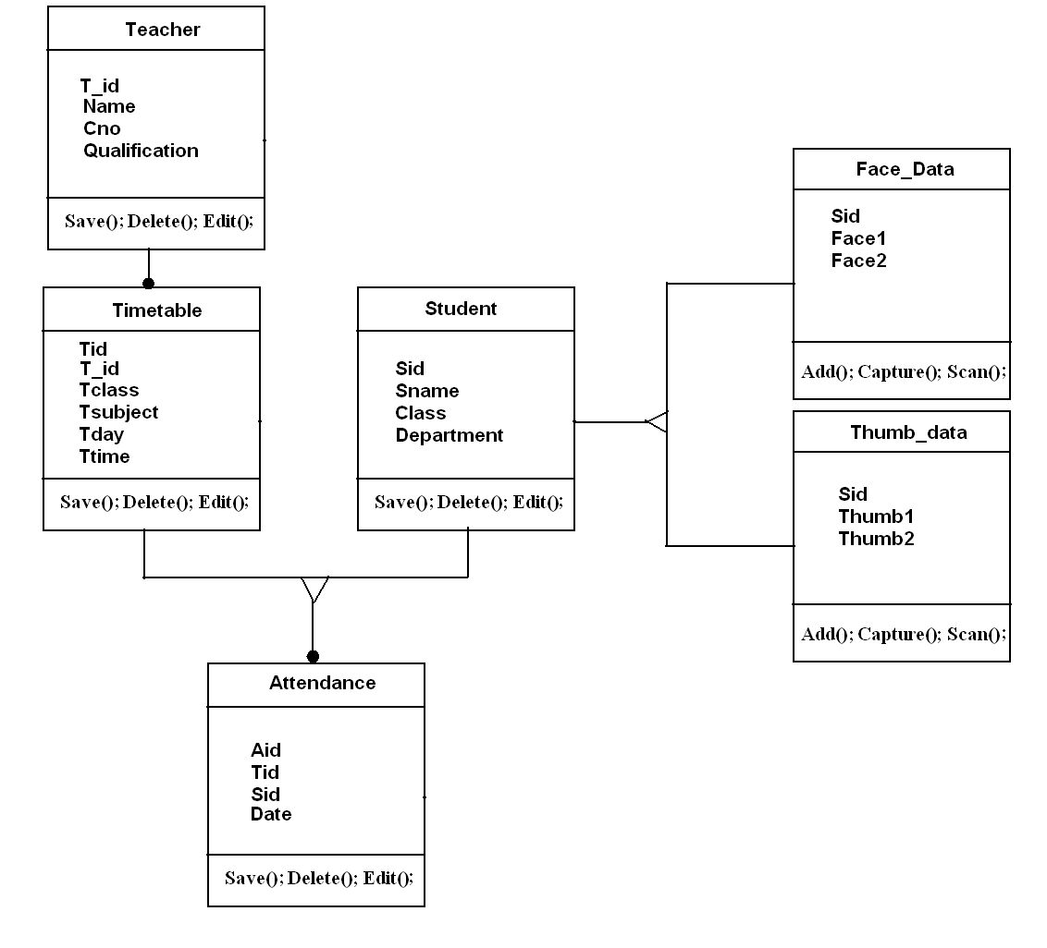

2.DFD

* DFD 0

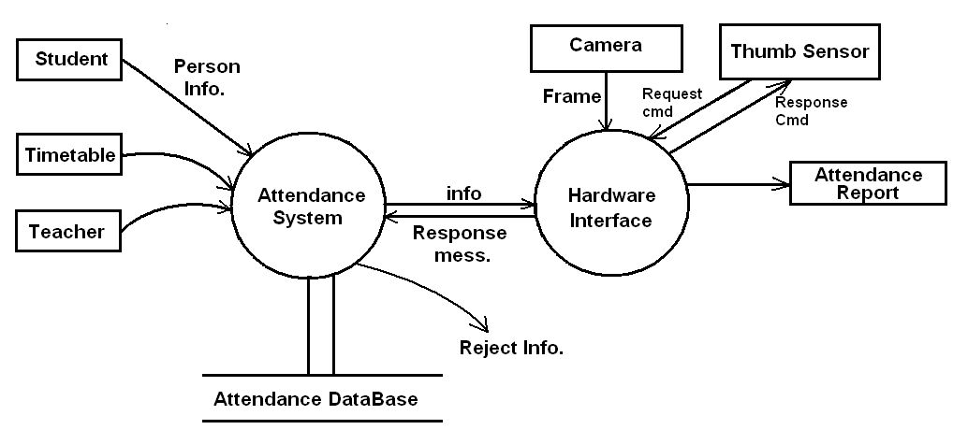

* DFD 1

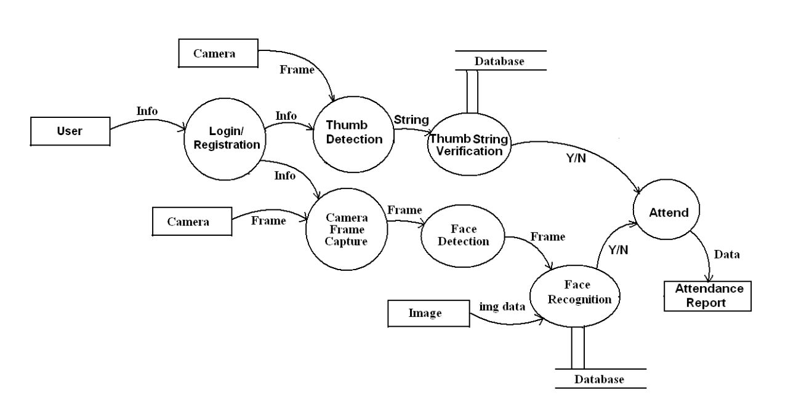

3.Sequence Diagram

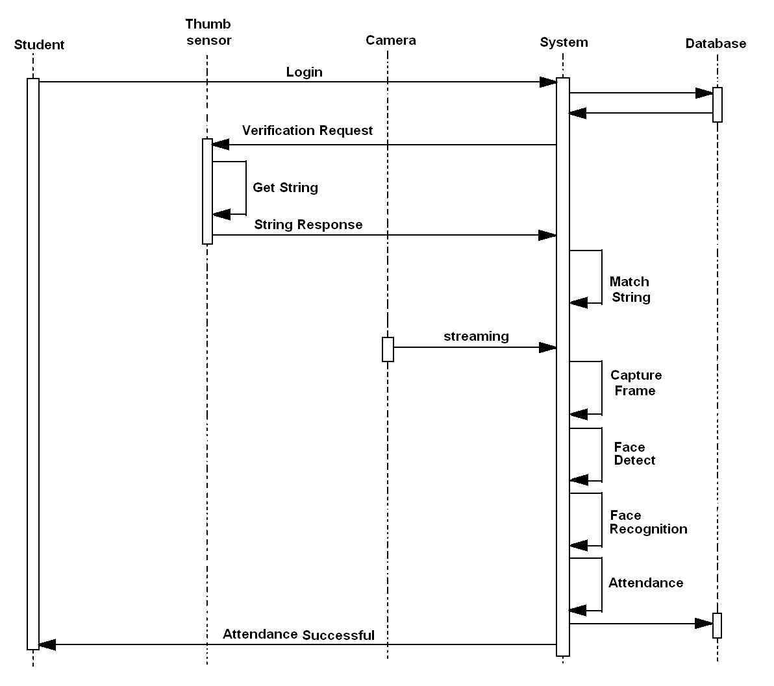

* MODULES

1.Login Registration

* + - Teacher login registration

2.Thumb Recognition

* + - Thumb scanner
    - Thumb verification
    - Match image

3.Face Recognition

* + - Frame Capture
    - Image Enhancement
    - Face Detection
    - Attendance management
    - Attendance server
    - Database
* **TECHNOLOGIES**

1.Software Requirements

* + - PHP
    - .NET Framework
    - Open CV

2.Hardware Requirements

* + - RAM:-512MB onwards
    - PROCESSOR:-1.2GHz dual core onwards
    - HARDISK:-3GB onwards
* EXPECTED OUTPUT
* Thumb Verified
* Face Verified
* Report Generation
* REFRENCES
* International Journal for Innovative Research in Science and Technology Volume1-Issue 11 April2015.
* <http://www.slideshare.net/rajsharma528/project-reportonstudentinformationmanagementsystemphpmysql>.
* M. Mattam, S. R. M. Karumuri, and S. R. Meda, “Architecture for Automated Student Attendance,” in Proc. IEEE Fourth International Conference on Technology for Education (T4E 2012), pp.164-167, 18-20 July 2012, doi: 10.1109/T4E.2012.39.